1.write a c program to calculate ncr value

Code:

#include <stdio.h>

long long factorial(int n) {

if (n == 0 || n == 1)

return 1;

return n \* factorial(n - 1);

}

long long nCr(int n, int r) {

if (r > n)

return 0;

return factorial(n) / (factorial(r) \* factorial(n - r));

}

int main() {

int n, r;

printf("Enter value of n: ");

scanf("%d", &n);

printf("Enter value of r: ");

scanf("%d", &r);

printf("Value of %dC%d is %lld\n", n, r, nCr(n, r));

return 0;

}

Output:

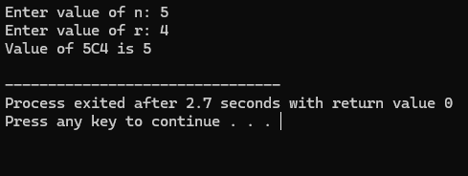

2.write a c-function to transpose matrix:

Code:

#include <stdio.h>

int main() {

int rows, cols;

printf("Enter number of rows: ");

scanf("%d", &rows);

printf("Enter number of columns: ");

scanf("%d", &cols);

int matrix[rows][cols];

int transpose[cols][rows];

printf("Enter elements of the matrix:\n");

for (int i = 0; i < rows; i++) {

for (int j = 0; j < cols; j++) {

scanf("%d", &matrix[i][j]);

}

}

// Calculating transpose

for (int i = 0; i < rows; i++) {

for (int j = 0; j < cols; j++) {

transpose[j][i] = matrix[i][j];

}

}

printf("Transpose of the matrix:\n");

for (int i = 0; i < cols; i++) {

for (int j = 0; j < rows; j++) {

printf("%d ", transpose[i][j]);

}

printf("\n");

}

return 0;

}

Output:

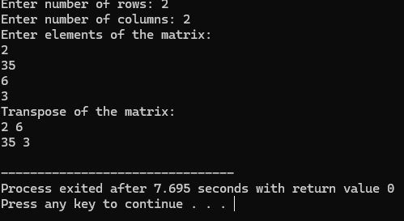

3. write a recursive function to generate fibanocci number

Code:

#include<stdio.h>

int fibanocci(int n){

if(n==0)

return 0;

else if (n==1)

return 1;

else

return fibanocci(n-1)+fibanocci(n-2);

}

int main(){

int n;

printf("enter no of fibanocci numbers to be generated=");

scanf("%d",&n);

printf("fibanocci series:");

for(int i=0;i<n;i++){

printf("%d\t",fibanocci(i));

}

printf("\n");

}

Output:

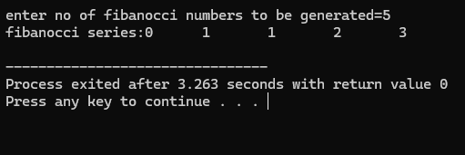

4.write a recursive program to find LCM of two numbers

Code:

#include <stdio.h>

int Lcm(int a,int b, int multiple){

if(multiple % a == 0 && multiple % b == 0)

return multiple;

else

return Lcm(a,b,multiple+1);

}

int main(){

int a,b;

printf("enter the values of a,b:");

scanf("%d%d",&a,&b);

int result=Lcm(a,b,(a>b)?a:b);

printf("LCM of %d and %d is:%d",a,b,result);

}

Output:

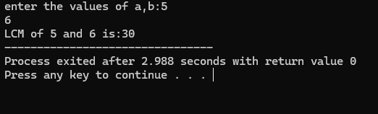

5.write a recursive function to find the GCD of two numbers:

Code:

#include <stdio.h>

int GCD(int a,int b){

if(b==0)

return a;

else

return GCD(b,a%b);

}

int main(){

int a,b;

printf("enter the values of a,b:");

scanf("%d%d",&a,&b);

printf("GCD of %d and %d is:%d",a,b,GCD(a,b));

}

Output:

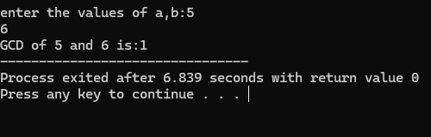

6.write a recursive to check the numer is palindrome or not:

Code:

#include <stdio.h>

int reverseNumber(int num, int rev) {

if (num == 0)

return rev;

rev = rev \* 10 + (num % 10);

return reverseNumber(num / 10, rev);

}

int isPalindrome(int num) {

if (num < 0)

return 0;

return (num == reverseNumber(num, 0));

}

int main() {

int number = 121;

if (isPalindrome(number))

printf("%d is a palindrome\n", number);

else

printf("%d is not a palindrome\n", number);

return 0;

}

Output:

